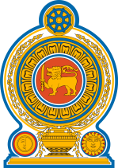

The Department of Immigration & Emigration of Sri Lanka has announced establishing of a new simplified e-Visa scheme replacing the former Electronic Travel Authorization (ETA) system to issue visas to visit Sri Lanka. Under the new scheme all visitors must complete an eVisa application prior to their arrival in the country through the eVisa site of the Department ( http://www.srilankaevisa.lk/).

For further information and applying for eVisa, kindly visit the following websites of the Department of Immigration and Emigration of Sri Lanka.

https://www.immigration.gov.lk/index_e.php
https://www.srilankaevisa.lk/

