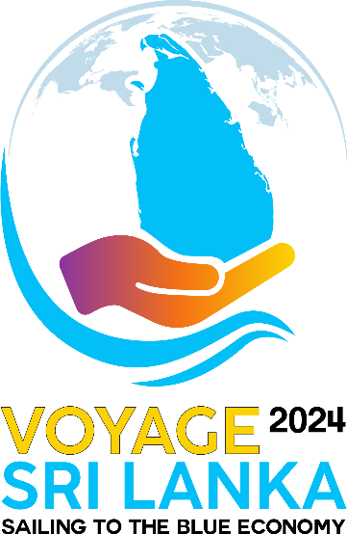

Social media Links
----------------------------------------------------------

Facebook Page

- https://www.facebook.com/profile.php?id=61566945500172&mibextid=rS40aB7S9Ucbxw6v

LinkedIn Page

- https://www.linkedin.com/company/voyage-sri-lanka/

Instagram Page

- https://www.instagram.com/voyagesrilanka2024

Official Website

- https://voyagesrilanka.lk/

Boat Building video
https://www.youtube.com/watch?v=3LuEopKHlPA

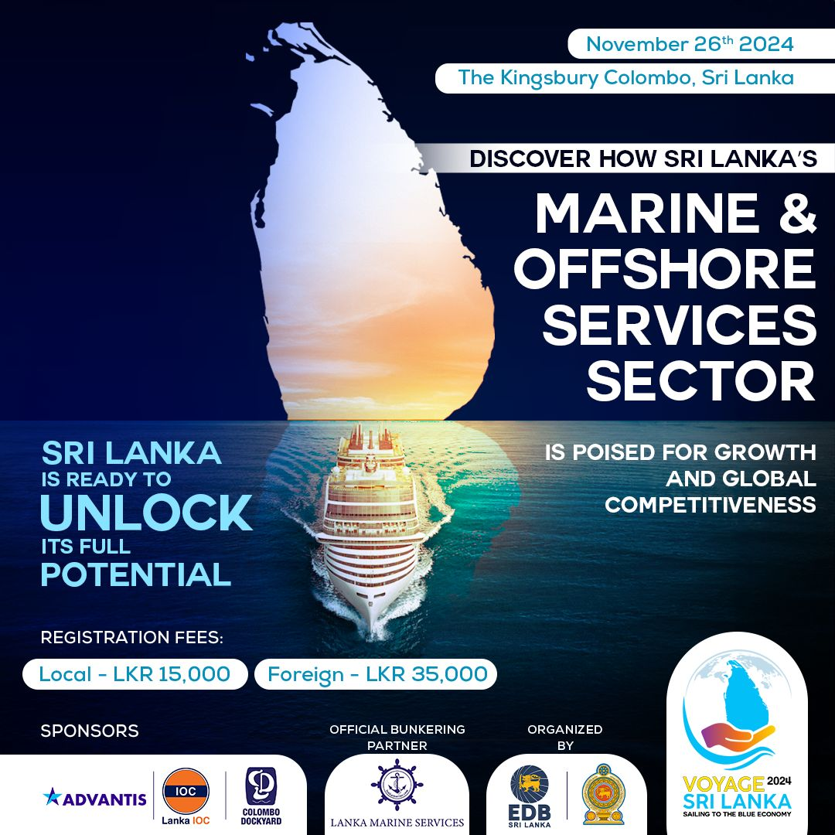
Static Image to promote the event

